ASSOCIATION OF PUBLIC ADMINISTRATION RESEARCHERS

3RD PRE - NATIONAL CONFERENCE VIRTUAL SYMPOSIUM
BOOK OF PROCEEDINGS JUNE 15, 2O23


THEME:
Foundation for a New Nigeria and Hope for National Development

2ND PRE - NATIONAL CONFERENCE VIRTUAL SYMPOSIUM BOOK OF PROCEEDINGS, JUNE 15, 2023

(c) Association of Public Administration Researchers

Published by:
Association of Public Administration Researchers
C/O Professor Akongbowa Bramwell Amadasun
Department of Public Administration Federal
University Wukari, Wukari, Taraba State, Nigeria.
EMAIL: aamadasun@fuwukari.edu.ng ab.amadasun16@gmail.com
CELL: +2348039445333, +2348055612923

All rights reserved under copyright Conventions. This book may not be reproduced in whole or in part, in any form or by any means electronic or mechanical, including photocopying or by any information storage and retrieval system now known or hereafter invented, without written permission from the copyright owner or publisher

ISBN: 978-978-60959-8-6-7

EDITORIAL BOARD

Editors

Professor Akongbowa Bramwell Amadasun, Department of Public Administration, Federal University Wukari,Wukari, Taraba State.
Editor-in-Chief

Professor C. J. Duru, Department of Public Administration, University Calabar, Calabar, Cross Rivers State
Deputy Editor-in-Chief

Professor Fidelis Osinachi Okpata, Department of Political Science, Alex Ekwueme Federal University, Ndufu-Alike, Ebonyi State.
Managing Editor

Dr. Philip Dahida, Department of Public Administration, University of Abuja,
Abuja (FCT).
Editorial Assistant

Dr. Adekeye Joseph Adeshola, Department of public Administration, Federal University, Lokoja, Kogi State.
Editorial Assisstant

Dr. Marvelous Oiakhena, Department of Public Administration, Samuel Adegboyega University, Ogwua, Edo State.
Editorial Assistant

Editorial Consultants
Professor Chika Njideka Oguonu, Professor of Public Administration and Local Government, Department of Public Administration, University of Nigeria,
Nsukka, Enugu State.

Professor Ukertor Gabriel Moti, Department of Public Administration,
University of Abuja, Abuja (FCT).

Professor Daniel Tonwe, Department of Public Administration, University of Benin, Benin City, Edo State

Professor James A. Ojobo,
Department of Public Administration, University of Abuja,Abuja (FCT)

TABLE OF CONTENTS
PAGE

Editorial Board 3

Table of Content 4

Requirements for Performing Medical Service
Delivery Architecture:
In Search of Dynamic Models
Professor Ibiyemi Olatunji-Bello 5

Managing Nigeria’s Environmental Waste: Perspectives
and Challenges in Urban Waste Disaster Management
Professor Uche Nnadozie, Ph.D, FASPAR 27

REQUIREMENTS FOR PERFORMING MEDICAL SERVICE DELIVERY ARCHITECTURE:
IN SEARCH OF DYNAMIC MODELS

PROFESSOR IBIYEMI OLATUNJI-BELLO
VICE CHANCELLOR, LAGOS STATE UNIVERSITY (LASU), OJO-LAGOS

A paper presented at the 3rd Pre-National Conference Virtual
Symposium of the Association of Public Administration
Researchers (ASPAR), held on the 15th June, 2023.

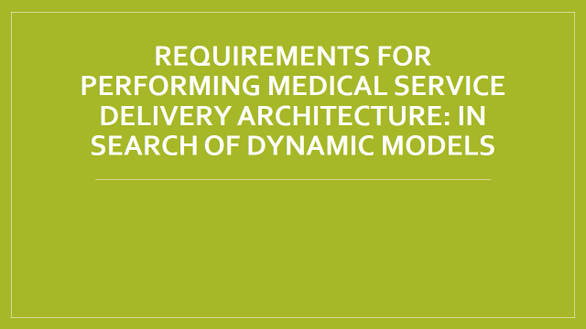

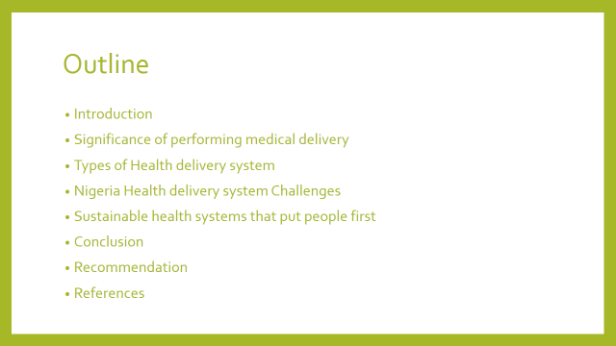

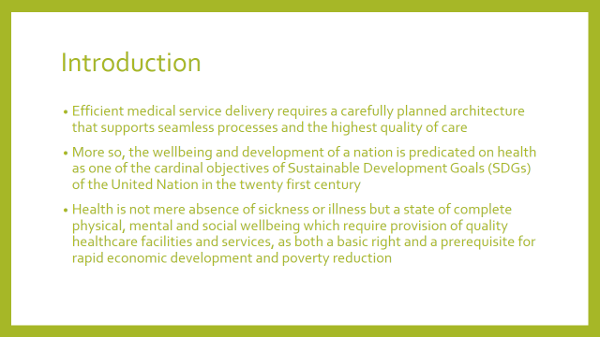

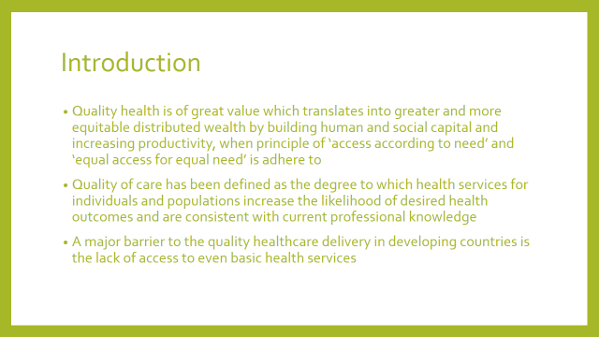

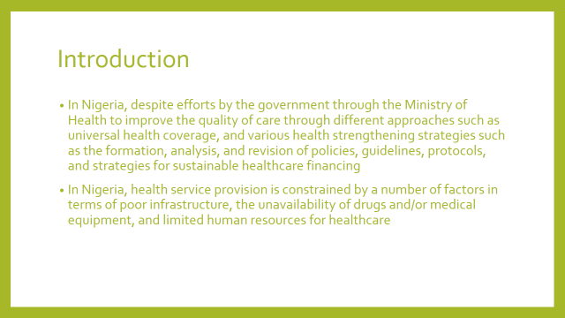

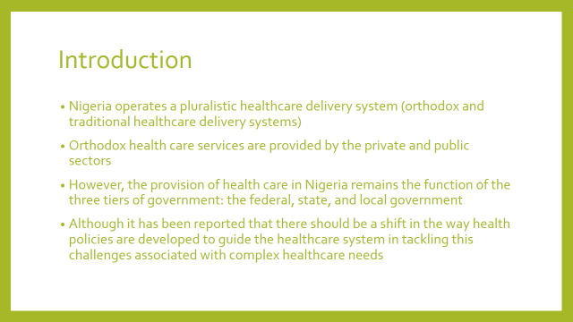

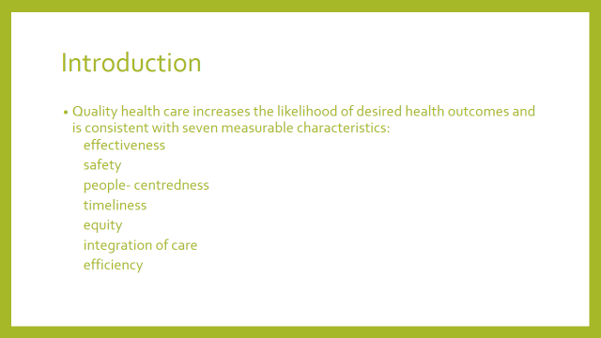

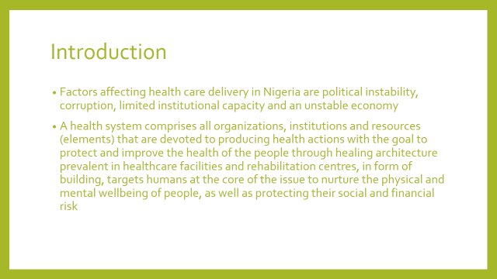

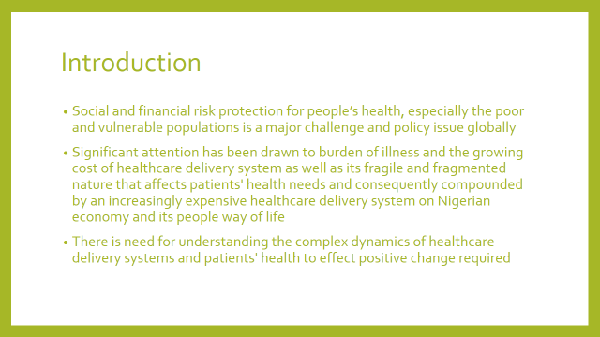

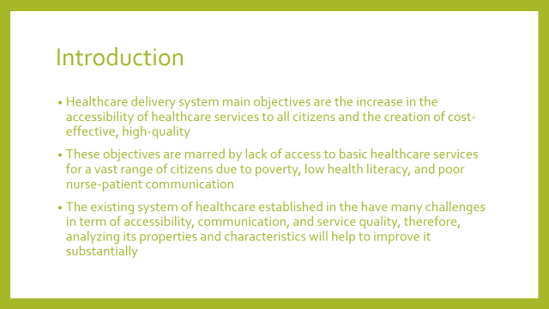

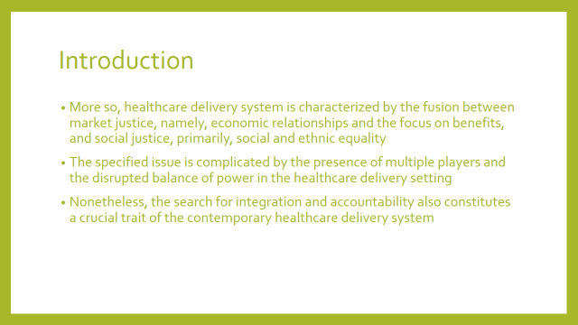

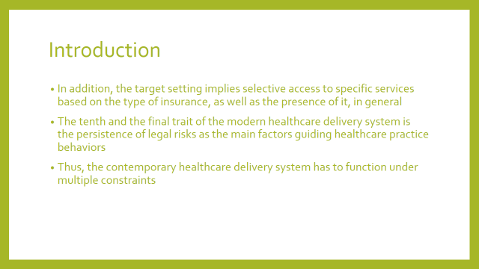

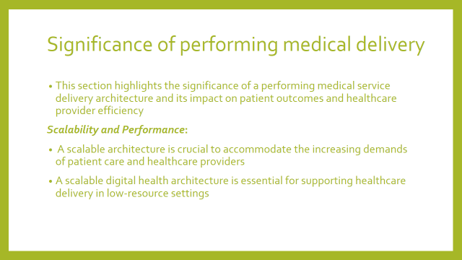

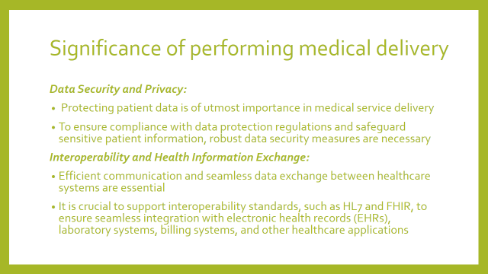

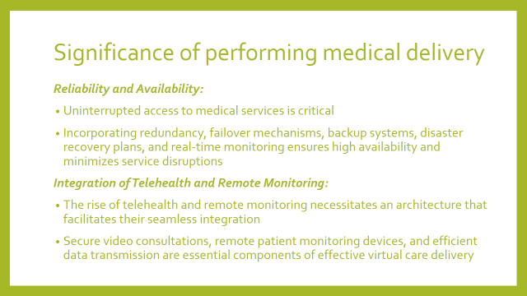



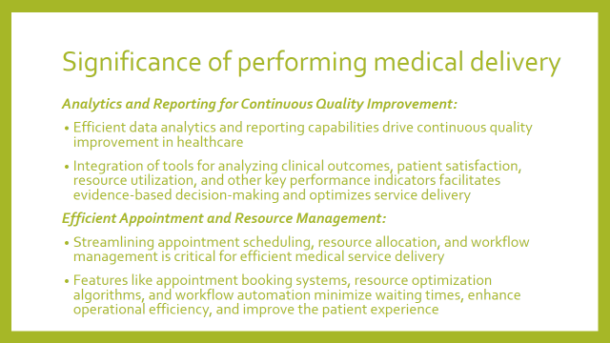

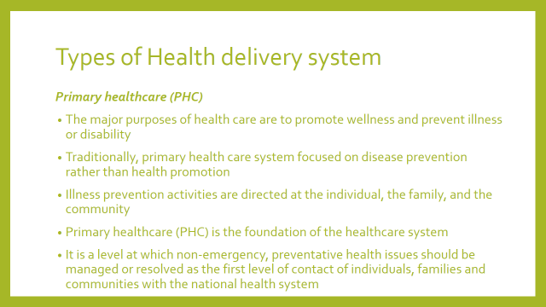

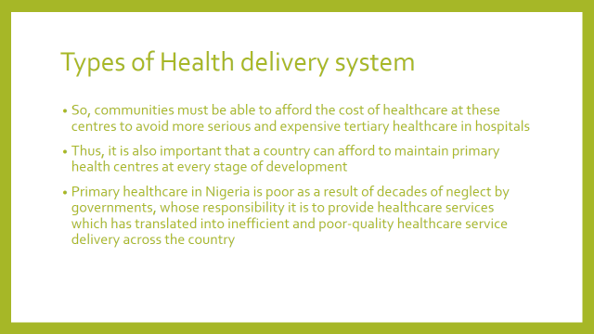

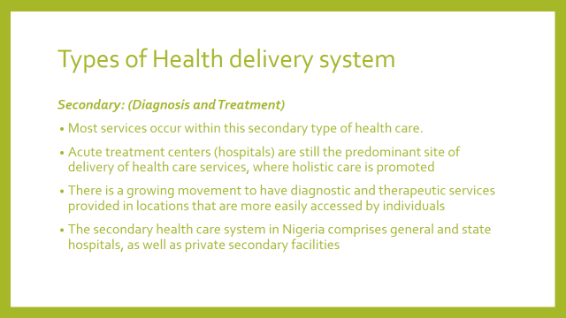

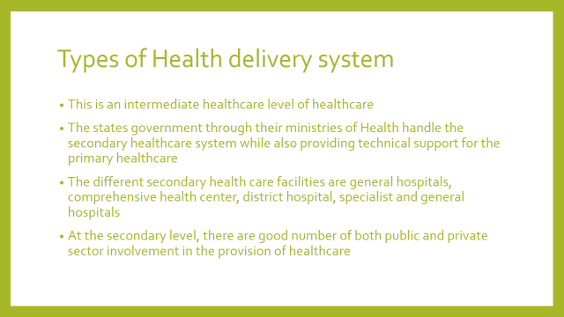

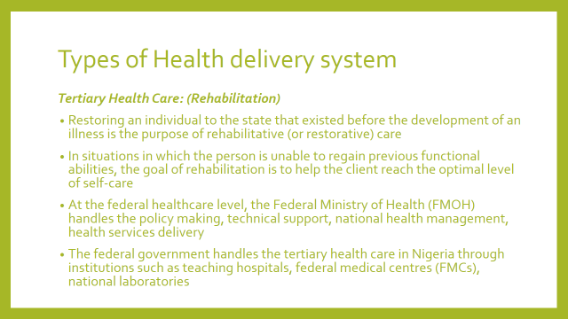

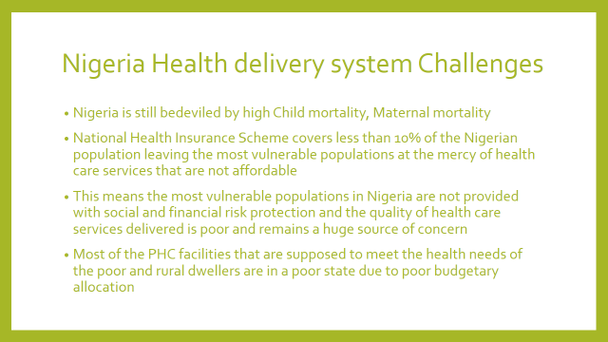

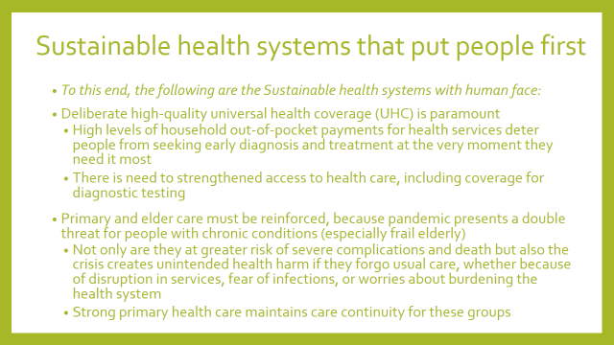

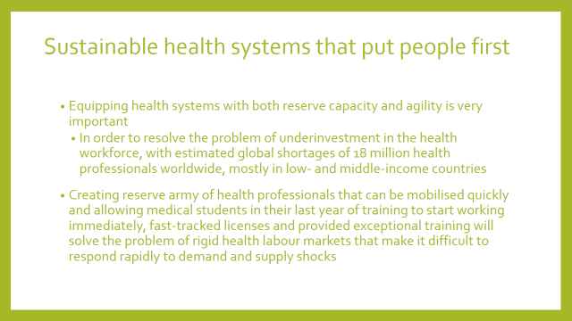

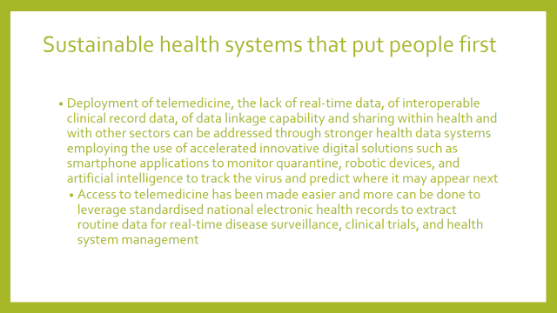

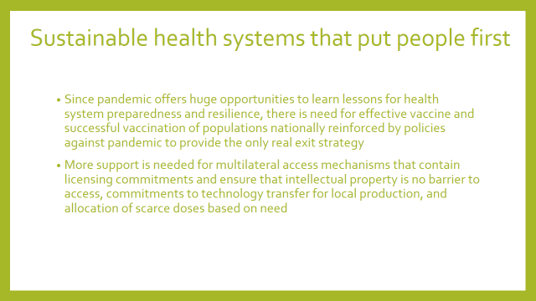

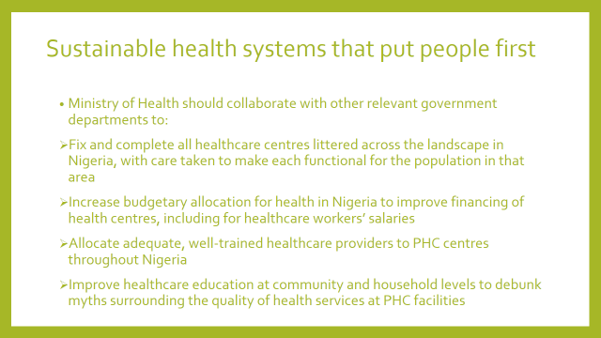

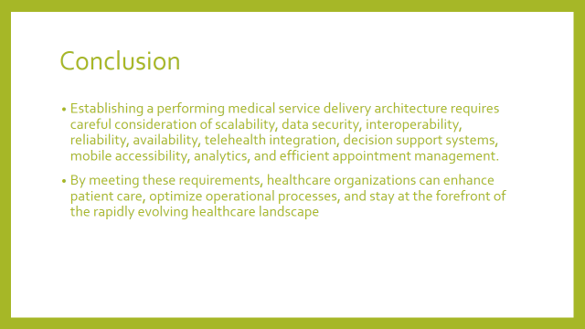

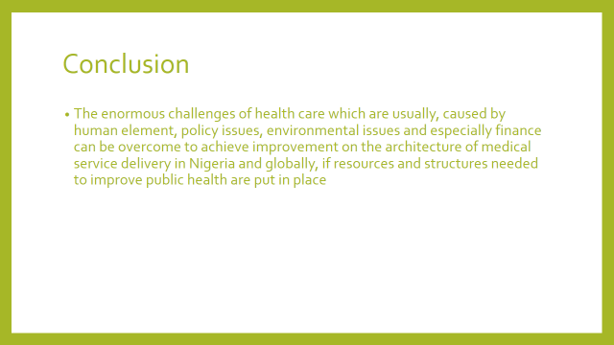

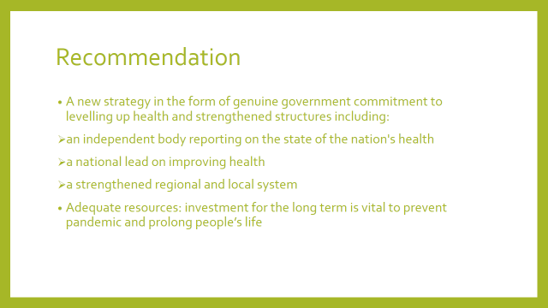

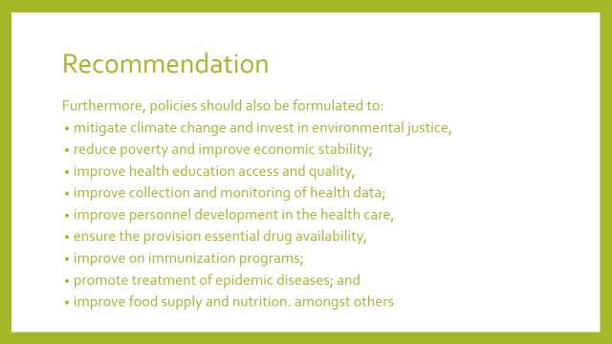

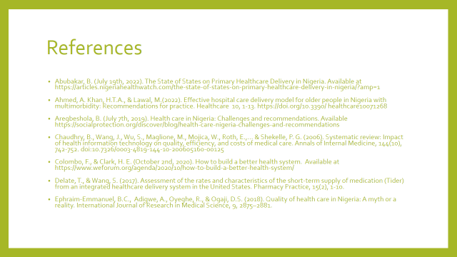

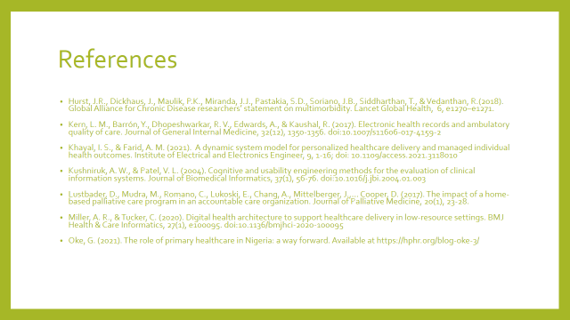

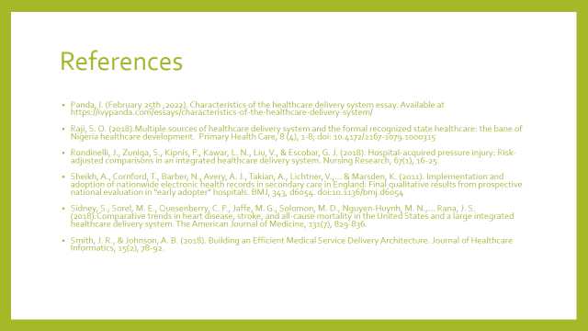

MANAGING NIGERIA’S ENVIRONMENTAL WASTE: PERSPECTIVES AND CHALLENGES IN URBAN WASTE DISASTER MANAGEMENT

Professor Uche Nnadozie, Ph.D, FASPAR
Department of Public Administration and Local Government (PALG)
University of Nigeria, Nsukka

A paper presented at the 3rd Pre-National Conference Virtual
Symposium of the Association of Public Administration
Researchers (ASPAR), held on the 15th June, 2023.

Introduction
One current common and ugly feature of the Nigerian cities and urban areas is the prevalence of wastes and hips of rubbish in the streets and sometimes strategic places. Any casual visitor or even passers-by through our cities and urban areas cannot fail to notice the presence of these menace. The sights are indeed very nauseating, unwholesome and indeed quit disturbing. This situation clearly shows that we have Nigeria has a very serious challenge concerning the management of its wastes. However, it needs to be pointed out at this initial stage of our discussion that the problem of generation and management of wastes and their management is not peculiar to Nigeria. Rather it is a global challenge. But while some counties, especially the developed ones have been able to manage the problems fairly well, others such the underdeveloped countries like Nigeria would appear to be overwhelmed by the challenges associated with the collection and management of their wastes.
Nevertheless, it must also be pointed out immediately that waste and disaster management is a complicated issue often involving so many issues and inter-related dimensions. It therefore needs to be deliberately and skilfully planned and budgeted for. Again, as is often said with regard to security, the issue of waste and disaster management involves everybody and definitely not limited to government officials and state employees. For a successful management of wastes, all hands must be on deck, involving though not limited to state officials, market men and women, school authorities and their students, corporate bodies and organizations, community and traditional leaders, religious organizations and their members, etc.
In this discussion, several questions and issues shall be raised and attempts made to address them. These questions and issues include though not limited to what constitute environmental wastes and disaster and how can they be managed? What are some of the approaches and views often advocated for managing environmental wastes and disasters associated with them? What are the challenges that industrialization and urbanization made and are still making towards the generation and management of wastes and disasters? And how can the challenges and issues be handled to ameliorate the multi-dimensional health risks associated with wastes and disasters.
Background to Environmental Waste Generation and Management in Nigeria
As already noted above, the management of environmental wastes and their attendant disasters is a world-wide phenomenon and not necessarily peculiar to Nigeria. At the beginning of human existence, waste generation and disasters associated with it was very minimal. This is essentially due to low level of population density and minimal exploitation of world natural resources. The most prominent wastes generated in villages and rural communities was essentially ashes and human biodegradable wastes. These were released back into the ground within the local communities with little or minimum environmental impact. Instruments made of wood or metal were generally re-used or passed down through generations. Nevertheless, some civilizations were more profligate than others in their waste production. Consequently, in some climes, there were more organized form of waste disposal. This was the case, for example, in the Maya of Central America which has a fixed monthly ritual where the people of the village gathered together to burn their rubbish in large dumps (Barbalace, R. C. 2003).
However, with the onset of modernization, especially following Industrial Revolution which started in Britain and spread to other parts of Europe and sustained urban growth of big population, the generation of waste in cities and towns caused a rapid deterioration of in levels of sanitation which greatly affected the health of urban dwellers and the general quality of life in cities and urban centres. The streets were gradually choked with filth due to lack of waste disposal emanating from lack of legislations on urban planning and waste management (Nightingale, R , 2014). Consequently, there were calls and agitations for the enactment of laws and legislations on waste management including the establishment of municipal authority with vast disposal powers in the 16th century, particularly in 1751 when Corbyn Morris in London proposed that “…as the preservation of the health of the people is of great importance, it is proposed the clearing of this city, should be put under one uniform public management, and all the filth be …conveyed by the Thames to proper distance in the country” (Herbert. L, 2007).
Nevertheless, it was not until the middle of th19th century triggered off by increasing devastation of cholera outbreaks and the consequent debate on public health that the first attempt to legislate on waste management started. Highly influential in this awareness on this movement, as it were, and indeed the central figure in the debate was the report titled The Sanitary Condition of the Labouring Population’ in 1842 by the Social reformer, Edwin Chadwick, in which he argued for the need to take appropriate legislative action on adequate waste removal and management to protect the health and welfare of the city’s population (Chadwick, E. 1842).
What Constitutes Environmental Waste and Disaster?
Waste can be classified into different forms. The World Health Organization defines waste as ‘’something which the owner no longer wants at a given time and space and which has no current or perceived market value’’ and this definition represents a broad-based approach to the classification wastes (cited in Ogbonna, et al, 2002). Waste can also be classified from its source of generation. When they are produced from the home, they are known as house-hold waste, from the office or shop they are referred to as commercial waste; when generated from the factories or an industry, they are called industrial waste, which include waste from oil extraction industries with particular reference to the Niger Delta Region of the South-South geo-political zone of Nigeria where the issue of environmental oil pollution has assumed has assumed an international dimension. Waste can equally be classified according to the problem or disease it causes.
The Oxford English Dictionary defines waste as “superfluous, refuse or rejected material’’. On its part, the Lagos State Environmental Sanitation Edit 1985 in section 32 defines waste to include (a) waste of all description, (b) any substance which constitutes scrap material or an effluent or other unwanted surplus substance arising from the application of any process (cited in Akpoghome, 2014). But it should be pointed out here that what constitute a waste may not be completely useless. This is due to the fact that it can be recycled to produce a new product.
Again, waste can be classified from the point of view of the nature of its content. In this regard, environmental waste can be solid, liquid or gas. It can also be organic or inorganic. Organic wastes can decay. Organic wastes include those substances and materials which rot and are absorbed back into the soil. They often serve as manure which enriches the soil and serves as fertilizer for agricultural purposes. On the other hand, inorganic wastes cannot decay and are often managed differently from those of their organic counterparts (Akpoghome, 2014).
Each of these wastes has different methods of collection, transportation, disposal and general management. Breaking them further, wastes can also be differentiated, in addition to those already mentioned above, to include biological, municipal, biomedical and radioactive wastes. As the name implies, these wastes impact on the environment in very varying negative ways. All these negative ways affect adversely on the health and wellbeing of the citizenry. Furthermore, the need to distinguish and classify wastes is very important. This is because wastes have both local or national and international markets. Indeed, the sale or marketing of wastes have become a lucrative business in which people are not only making a living from but are becoming established on them. This is due to the fact that wastes are economic goods that are collected, bought and sold and transported across land and sea. Indeed, the definition and classification of wastes have become the basis for agreed Protocols on which they are packaged, managed and marketed (Akpoghome, 2014).
On the whole, the essence of waste management is to mitigate the adverse effects of their negative impact on human wealth, the environment, planetary resources and increase or bring out the aesthetic character of the environment and human nature. This is why it has been pointed out that an environmental waste management system (EMS) is a “’system which integrates policy, procedures and processes for training, monitoring, summarizing and reporting of specialized environmental performance information to internal and external stakeholders ….” (Levis, 2007).
Disaster and Disaster Management in Nigeria
Disaster is defined by Webster’s Collegiate Dictionary as “a sudden calamitous event bringing great damage, loss or destruction; a sudden or great misfortune’’. When this is added to the adjective environmental the full picture is obtained, that is, environmental disaster. This can be interpreted to mean a sudden calamitous event in an environment that brought about terrible damage, loss or destruction. This kind of scenario can be caused by natural events such as great flood consequent upon torrential rain fall, earthquake, volcano, tsunami and similar occurrences. It can also be brought about by human activities such as construction activities. But it is worst when disasters are caused by combination of both natural and human activities. However, our concern here is how they are managed.
On this score, it be said that there is no known standard or universally accepted means of managing disaster. Therefore, disaster management varies from place to place and is conditioned by the nature or character of the disaster including its level and what brought about the disaster. Nevertheless, disasters are better managed when they are predicted and looked forward to or anticipated and therefore planned for. And there are experts who help in the prediction and planning for the management of disasters. These include climatologists, geologists, country or town planners and similar professionals. These are the class of people who study and predict the weather, earth movements and our environments in general. They assist in establishing what are likely to happen in an environment, when and how they are to occur.
On the basis of their studies, they can predict and warn us to be prepared or expect disasters; but more importantly, advise or warn us on what to do, or what not to do especially with regard to construction and other activities in order to lessen or minimise the impacts of such natural disasters whenever they occur as they cannot they be completely eliminated or prevented from happening. It may need to be added immediately that environmental disaster management can be said to be centred on planning so as to minimise or lesson its impacts on humans. It is important to stress that it is expensive and must therefore be adequately budgeted for as therefore are signs that are looked out for on the bases of which the citizens are alerted or warned in advance.
Environmental Waste Dumping and Management Practices in Nigeria
Nigerians would appear to perceive the production of wastes and its pollution as a necessary outcome of industrialization and development. Waste production in Nigeria are increasing on daily basis. Unfortunately, their management is not given the commensurate attention they need and this is not helped by “a cycle of poverty, population explosion, decreasing standard of living, bad governance, and the low level of environmental awareness’’ (Ogbonna, et al, 2002: 55). And it should be added also increasing rural – urban migration, rapid and haphazard industrialization and inevitable increase in waste generation. Many cities and urban centres generate more wastes than they can manage. This situation tends to worsen with increase in population growth, income levels and economic activities. Generally, low income areas including slums and shanties receive least attention with regard to waste collection and disposal. Urban Waste Management authorities and their workers who redeem recyclable materials from richer refuge dumping areas have little or no incentives to extend their services to poor urban settlements and slums. Consequently, wastes are dumped indiscriminately (Izeze, I, 1999, cited in Oghanna, et al, 2002).
The issue of waste management in Nigeria has become a national concern. This is because heaps of refuge are often dumped along major roads and city centres, river banks and open available spaces across the country. Even our university campuses and other institutions of higher learning, as well as secondary schools are not left out in this mess, as refuse dumps are now part and parcel of their landscapes. A visit to major Nigerian cities such as Lagos, Abuja, Enugu, Owerri, Onitsha, Aba, Port Harcourt, Kaduna, Kano, Benin, among others reveals the presence of heaps of garbage and wastes along the roads, streets, market places and motor parks.
In recognition of this national malady, past governments in the country have attempted to tackle the management of wastes through the ‘task force’ approach. This method involved the setting up of different types of task force to handle the collection, transportation and general management of wastes across the country. But the approach would appear to have tackle the menace half way, as the wastes and refuge collected were often left at the various points of collection across the cities and urban centres without being cleared for days and weeks. This is mainly due to lack of synergy and coordination and technological know-how among the various bodies responsible for the exercise. As a means of further tackling the problem, the Federal government in 1985 initiated the National Environmental Sanitation/Cleaning Day Exercise popularly known as ‘Operation Clean Up Exercise’ in which every last Saturday of every month was declared a cleaning up campaign day.
On that day, every resident in Nigeria is required to come out on the streets and his/her environment or community to do a mandatary/compulsory clean up exercise between the hours of 6am to 10am. During this period of the day, there was no movement of any sort, including vehicular movements within and across the states of the Federation. The programme was generally enforced through a combination of various task forces made up of the army, police and other para-military agencies set up across the states of the country including Abuja. The initiative was largely commended and appeared to have yielded results, particularly during Military era as Nigerian major cities and urban centres started wearing new looks, especially days following the exercise.
But like most Nigerian programmes and projects, the campaign gradually lost its lustre, especially with the emergence of civilian regimes in 1999. The implementation of the exercise lost it zeal and commitment. Worse still, the garbage and wastes from the exercise were left unattended to and were left to decompose and to be eaten up by animals and to be washed away by rains and floods into gutters and drainage channels. The wastes blocked the gutters, water ways and drainage systems while some of them were washed onto the surfaces and roads thereby constituting another menace to the residents and cities. In the riverine areas and estuarine places, the wastes and garbage are usually washed away by tidal floods into the larger creeks, rivers and canals thereby affecting and destroying the quality of surface water (Nweke, A. A, 2000, cited in Ogbonna et al. 2002). When the wastes are eventually cleared, they found their way at the outskirts of cities, especially in abandoned excavation cites and pits, river channels, ravines and sometimes open spaces – a situation of waste transfer from locations, especially here high-brow parts of cities and towns where rich people feel inconvenienced to areas, especially down-town areas, slums and shanties where their nuisance is tolerated.
This kind of ‘waste transfer’ should not be considered not be considered an option in waste disposal as it is discriminatory as it simply transfers the problem from highly placed people to ‘the wretched of the earth’. In Rivers State, a multinational oil company operating in Nigeria in 1993 initiated plans to establish land-fill facilities for disposal of domestic and industrial wastes generated from its operations in the Niger Delta. But the ecological and other socio-economic issues in the Niger Delta region are impeding the implementation of project in Etche, Rivers State (Ogbonna, et al).
Another waste disposal practice occasionally employed in Nigeria is the incineration and composting system. This involves the reduction of combustible waste to inert residue by burning at very high temperatures. This process effectively reduces the volume of wastes that need to be disposed by up to 75 to95 percent. But as has been noted, only Lagos State government has incinerators, which due to poor management and maintenance have mostly broken down (Ogbonna, et al 2002). Composting, which is a biochemical process in which organic materials are biodegraded and decomposed to useful human-like materials, is often practised in major households and rural communities in Nigeria, It is particularly useful in communities where available arable lands for agricultural purposes are decreasing or scarce, bush following is no longer tenable, and the demand for compost as an alternative to artificial fertilizer has decreased in order to sustain intensive farming. But a major drawback to composting is the importance and indeed the necessity of separating biodegradable waste materials from other non-biodegradable materials before burning, which could be done at source. It is therefore recommended as it is economically advantageous that waste be separated at source before the commencement of the process.
In Nigeria, most factories and companies dispose of their wastes into nearby canals, rivers and creeks without any attempt to treat them or often at open dump sites. In Niger Delta region, the oil drilling multinationals dispose their wastes, especially cuttings, whether treated, partially treated or even not treated into nearby rivers, canals and creeks (offshore) or dug-out open pits (onshore). However, due to more stringent regulations of the Federal Ministry of Environment and Department of Petroleum Resources, some oil companies such as SPDC and EPNL have adopted the total containment option whereby their cuttings and wastes drilling fluid are re-injected into abandoned oil wells. Moreover, the waste minimization option is sometimes adopted by some oil companies in which on-site treatment of solid wastes are employed and waste recycling are undertaken (Ogbonndddkda, et al).
Some Legal Frameworks for Waste Management in Nigeria
This discussion on waste management cannot be concluded without bringing in the legal framework within which the issue of waste management in Nigeria is implemented. In this regard, it must be stated immediately that a number of laws have been put in place at both Federal and State government levels for the purpose of waste management in the country. These laws have also led to the establishment of institutions and agencies invested with powers to manage all issues connected with the management of wastes in the country. These include but not limited to the following:
      - Federal Environmental Protection Agency Act (FEPA of 1988);
      - Lagos State Environmental Sanitation Edith No. 3 of 1998;
      - Anambra State Environmental Authority Edith No.15 of 1985lfaak
      - Edo State Environmental Sanitation Edith of 1994;
      - Rivers State Environmental Sanitation and Protection Edith No.5 of 1986; and
      - Cross River State Environmental Sanitation and Protection Edith No. 6 of 1984.
A glance at these laws shows that all the states in the country that showed early concern on their environmental protection through legislation are in the southern part of the country and that all of them with the exception of Anambra states have boundaries or contact with the Atlantic Ocean. Even Anambra state which does not have direct contact with the Atlantic Ocean is inundated and almost surrounded by rivers and tributaries that empty into the Atlantic Ocean. One is therefore tempted to ask if large body of water has serious issues connected with environmental challenges and waste management. But this is a matter for another interrogation and does not border us here. Apart from these laws, it is necessary to note that the Nigerian Constitution, which is the fundamental law of the country also has some provisions concerning the protection of the environment for good life and welfare of the citizenry. In this regard, the 1990 Nigerian Constitution as amended, in section 20 provides that the “States shall protect and improve the environment and safeguard the water, land, forest and wildlife….”. Unfortunately, this provision of the people’s right to a protected environment is joined to be part of the fundamental objectives and directive principles of the state policy, which are covered in chapter 2 of the Constitution. The implication of this is that the provision is not justiciable, and that individuals cannot enforce their rights under this provision.
The discussion of the legal framework must look at the Federal Environmental Protection Agency Act (FEPA). This is because it was the first major environmental legislation passed in Nigeria. Though the Act has now been repealed and replaced by The National Environmental Standards and Regulations Enforcement Agency Act (NESREA) of 2007. But it deserves some mention albeit briefly. The agency was established by section 1 of the Federal Protection Agency Act as a body corporate with a common seal with the power to sue and be sued in its corporate name (Okukpon, A. O, cited in Okpoghome, 2014). The agency has broad powers. It was vested with the power the responsibility for the protection of the environment in Nigeria. Section 4 of the agency sets out the functions of the agency and stated that “The Agency shall, subject to this Act, have responsibility for the protection and development of the environment and biodiversity conservation and sustainable development of the nation’s natural resources in general and environmental technology, including initiation of policy in relation to environmental research and technology; ….”.
While the agency functioned, as already noted, it exercises wide powers. It had power to establish environmental standards in the country. The enforcement granted to an officer of the agency include powers to inspect without warrant, licenses, permits, certificates or other document required by law; it had powers to search, seize, enter any land, building , vehicle, floating craft, or any inland water or any other structure, in which he/she reason to believe that an offence against the Act has been committed; powers to perform tests with regards to substances relating to any offence which are found on the land, vehicle, tent, vessel, floating craft or any inland water or any structure searched in pursuance of this Act (Akpoghome. 2014).
At the States and Local Government levels, the Act provided that the Director-General shall encourage them to set up their own environmental agencies for the purpose of maintaining good environmental quality in their respective areas. In line with this guidance, various states established their own Environmental Protection bodies. But the Federal Environmental Protection Agency have been replaced in 1999 by the Federal Ministry of Environment. A new agency is now in place which took over the functions of FEPA. This is The National Environmental Standards and Regulations Enforcement Agency Act, which has since taken over all the functions and powers previously vested on FEPA (NESREA Act, 2007). In the same vein, most states have equally established their own ministries of environment to take over the powers and functions of State Environmental Protection Agencies, though some still retained the agencies but placed them under the parent ministries.
The National Environmental Standards and Regulations Enforcement Agency Act (NESREA), 2007
Like its predecessor, NESREA enjoyed a wide range of powers and if not more (see NESREA Act, 2007). It was established by section 1 of the NESREA Act as an institutional enforcement agency for environmental standards, regulations, rules, laws, policies and guidelines (1(2) (a) NESREA Act, 2007, cited in Akpoghome, 2014:12). It is a corporate body with perpetual succession and a common seal, and may sue and be sued in its corporate name. The functions and powers of the Agency are listed in sections 7 and 8 of the Act. In the conferment of powers on the Federal Minister of Environment by section 34 to make rules and regulations, there were provisions made for environmental sanitation management and waste control and the commencement date of the Act was 30th September, 2009.
The provisions contained in NESREA Act are quite enormous and are a great expansion of those contained in FEPA. As Akpoghome pointed out, NESREA Act made provisions for every minute details needed and it is the hope of concerned stakeholders that the agency shall live up to its responsibilities in the enforcement of the rules and regulations as contained in the legislation.
Challenges of Environmental Waste and Disaster Control in Nigeria
As can be seen from our discussion so far, it can be averred that the challenges associated with environmental waste and disaster control like many other problems in Nigeria, are not centred on lack of necessary and relevant rules, regulations and laws. Rather they can be easily attributed to the lack of the needed political will to enforce the various environmental laws and regulations and edits made to control and manage the situation. One can assert here without fear of contradiction that other problems militating against meliorating and solving the problems are closely linked with this political will to enforce the laws. Indeed, there is hardly any law that in needed to guide and enforce the issues associated with the collection, transportation and disposal of wastes that are not contained in the extant rules, regulations and laws either at the federal or state laws and edits, as well as bye-laws at the Local Government levels. Due to lack of time, one is constrained here to go along and add to what Okpoghome (2014:18-20) had outlined and simply name some of these problems.
They include but definitely not limited to:
            - Multiplicity of laws and agencies responsible for waste management;
            - Lack of modern technologies for the management of wastes;
            - Lack of trained personnel;
            - Inadequate funding of the agencies;
            - Lack of effective monitoring and control;
            - Illiteracy, apathy and lack of awareness on the part of the citizenry; and
            - Corruption and lack of commitment on the part of officials.

Multiplicity of Laws
Since challenges is one of the key issues in this discussion, it may be necessary to elaborate briefly the above problems. With regard to the first problem, it is necessary to point out that there is nowhere in the laws and regulations on the management of wastes in Nigeria where the waste management is made a partnership between the government and private individuals. But what is observed in most states is a situation where the responsibility and management of wastes is contracted to private businesses by the government. For instance, the Constitution of the Federal Republic of Nigeria as amended on the Fourth Schedule specifically vested the authority and management of waste on the local government council. But what is obtainable in most states of the Federation is that this authority and management has been given to contractors who churn out their own rules and regulations with exorbitant and strangulating fees which are usually forced down on the people.
Furthermore, the contractors often hire tugs who are flooded on major streets of cities and towns in different states of the Federation harassing and intimidating citizens on the basis of their own rules and regulations without regard to the extant laws and regulations of the State Edits on the management of wastes in the states. One of the consequences is that city and urban residents often resort to the dumping of refuse and wastes on any available spaces as only few individuals are ready to pay dues and fines to contractors who often are interested in the collection of dues and fines without little or no interest in the clearing of wastes and garbage.
Lack of modern technologies for Waste Management
One major problem in Nigeria with regard to waste collection and disposal is the issue of the use of archaic methods. Waste management involves the extraction of value from wastes in order to be recycled and used. And this entails the use of modern technology, which is not easily available in Nigeria. Waste management techniques often used in Nigeria some of which have been alluded to earlier include landfills, incineration and recycling. But the most popular are landfill and incineration; while recycling is the commonest method that is used in developed countries. It competes with new materials and this means the conservation of new materials.
The process of recycling starts from the moment the truck collects the garbage and wastes from the streets and dumpsters. The wastes are dumped into a conveyor belt where the sorting out begins. At this stage, suspicious packages such as bottles are removed into a special conveyor belt which is connected to a special machine that ca read the product bar code and sort the containers by its colour of glass, metal or resin. This process of waste management in Nigeria has started in big and largely populated cities such as Lagos, but its success has not been very remarkable.
Lack of Trained Personnel and Adequate Funding
These are other issues that need to be tackled if proper management of wastes in Nigeria is to be achieved. Waste management is a specialized business that need to have workers specifically and specially trained for the job. It is not an all comers job. This is why adequate training and funding go together. If qualified personnel for the management of wastes would be provided in the country, money has to be made available for it. But this has been shied away by Nigerian government at the three tiers. A situation where most State governments, for instance, contract the management of wastes to private businesses that are only interested in maximising profit cannot be expected to train and produce qualifies personnel for the job. There is therefore the need not only to adequately fund the various waste management agencies but also to employ properly trained personnel in their organizations.
Effective monitoring and control
There is also the need to monitor and control the dumping and disposal of wastes by the residents and the citizenry in general. A situation where individuals dump wastes indiscriminately should not be encouraged. A casual tour of the various dumping sited and designated dumping grounds reveal that sometimes kids and house-helps who are asked to dispose of their domestic wastes simply throw the wastes carelessly without attempting to put them into the containers provided for the purpose thereby making the clearing of the refuge more difficult for the workers involved in the exercise. This has sometimes necessitated the practice of arrest of the domestic waste disposers by the workers of the Enugu State Waste Management Authority (ESWAMA) employees during the monitoring of such exercises in the state in the 1990s. The authority has also attempted to provide water-proof bags specifically designed for dumping of refuge in urban areas in the state, especially Enugu the state capital. Such control and monitoring measures should be encouraged and emulated by other states in Nigeria, though it created its own problems such as arbitrary arrest and detention of residents which can be checkmated.
Illiteracy, Apathy and Unawareness
There is also the need to educate the generality of Nigerians on the laws and regulations guiding the proper disposal practices in our waste management extant Edits in the country. It does not make sense for time and resources to be expended on the formulation of elaborate laws and legislations when the generality of the populations is hardly aware of the laws and regulations. Because this writer has once been involved in some of the cleaning exercises during the Operation Keep Nigeria Clean of the Military era, especially during the preparations and campaign by the Federal government to host the aborted Junior World in the country, the general impression one gathered from the monitoring exercise was that the generality of Nigerians is often unaware of the laws and regulations guiding the dumping of refuge and wastes in the country. From their looks and utterances when caught, one can easily deduce that they are completely unaware of how, where and when to dump their domestic wastes and refuge.

Corruption and Lack of Commitment by Waste Management Officials
There is hardly any challenge bedevilling Nigeria that is not linked to corruption. As a result, those of waste management cannot therefore be an exception. The issue of corruption in waste management essentially the officials of the various agencies involved in the management of wastes in the country, especially at the highest echelon of the government. Like most political and government officials, members of the Nigerian political elite would find a means of exploiting and maximizing any office they find themselves. For instance, it has been alleged that one of the major reasons behind the striping of the powers of Enugu State Waste Management Authority (ESWAMA) by the State government during the Administration of Governor Ifeanyi Ugwuanyi and given to a special committee for that purpose was to create jobs for his friends and accolades. An investigative report published by Arinze Chijioke stated that the Committee, which was only answerable to the governor, was said to have awarded the contracts for the management of wastes in the state to its members. The result was that “The Ugwuanyi administration failed to maintain the waste disposal compactors provided for maste management and now relies on rickety trucks that take takes days to clear wastes (Ikegaonline,2023:18).
Way Forward
This discussion would like to conclude by associating itself with the recommendations of Bea Johnson in 2013, which was anchored on the five R’s of environmental management that was made in the 1970s (citied in Nnamani and Odo 2021). These Five R’s include:
- Refuse: Reducing waste is the most we can do, by reducing waste, we avoid unnecessary use of resources such as materials, energy and water. It means there is less waste to manage. How we can reduce waste:
i. Buy in bulk to reduce packaging
ii. Buy reusable items rather than disposable ones
iii. Stick to no junk mail, stick to letter box electronically.
- Reduce: It is all about reducing your use of harmful, wasteful and non-recyclable materials to save your money and the environment. By limiting your dependency on these type of products, this leads to lesser waste ending in landfill.
- Re-use: Re-using waste materials; in that way it does not end up in landfill. It also means you do not have to buy a new product. This saves you money, energy and resources. How do we re-use waste?
                - donate old books to schools and libraries rather than disposing them.
                - Use plastic materials for storing food items
                - Take household items to your council’s resource recovery centre
- Recover: This means recovering waste without any pre-processing.
For example: waste oils that cannot be refined for reuse in vehicles can be burnt for energy recovery. Recovering the energy from waste oil reduces our dependence on coal and imported oil.
- Re-cycle: This involves some form of reprocessing of waste materials to produce another product.
For example: re-cycling plastic bottle to make plastic buckets. Materials that can be recycled are paper, cardboard, glass, aluminium, tin and plastic containers. Composting and warm farms are method of recycling organic wastes.

References
Akpoghome, T.U. International Journal of Environment, Ecology, Family and Urban Studies (IJEEFUS), 2014.
Arinze, C. (2023): A research by Ikengaonline in collaboration with Dataphyte under the auspices of the Wole Soyinka Centre for Investigative Journalism (WSCIJ)
Barbalace, Roberta Crowell (1 August 2003). “The History of Waste”. Environmental Chemistry.com Retrieved 9 December, 2013.
Chadwick, Edwin (1842). Report… from the Poor Law Commissioners on an Inquiry into the Sanitary Conditions of the Labouring Population of Great Britain. London. Pp.369-372.
Herbert, Lewis (2007). “Centenary History of Waste and Managers in London and South England”. Chartered Institution of Wastes Management.
Murti, R. (2018, June 01). Environment and Disasters. Retrieved February 24, 2021, fromhttps://www.iucn.org/theme/ecosystem-management/our work/environemnt-and-disasters.
Nnamani, E.C and Odo, O.D (2021) Effective Waste Management in Nigeria: An Approach for Sustainable Development April
Ogbonna, D.N et al. (2002), A Tool for Environmental Protection in Nigeria, Royal Swedish Academy of Science.

